**Vaishali Poles**

Refer link for website - <http://auraenergy.com/>

Slide 1

Make a slide base on below slide

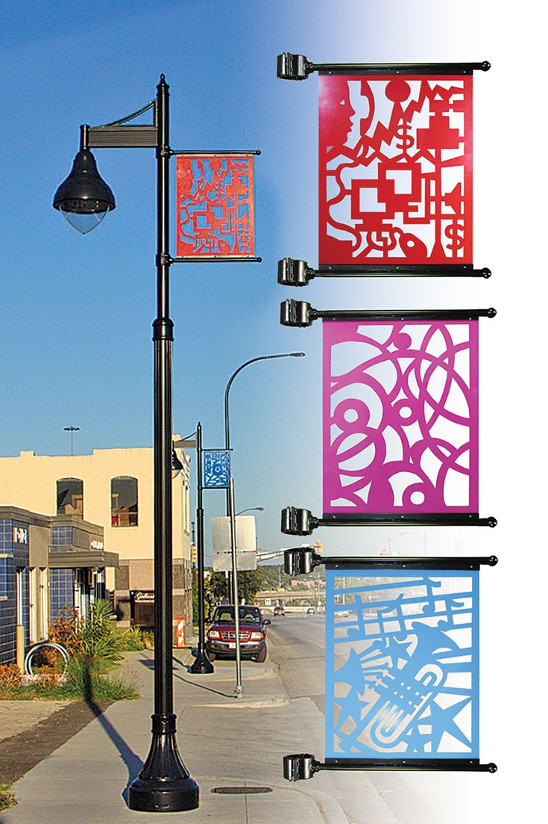 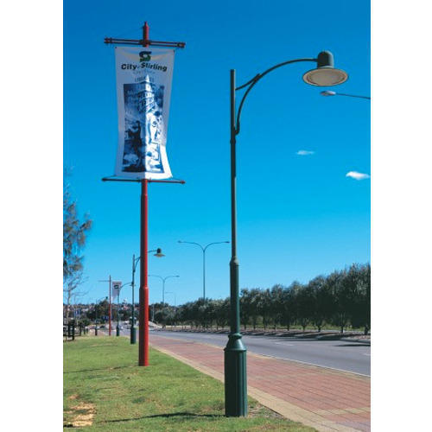

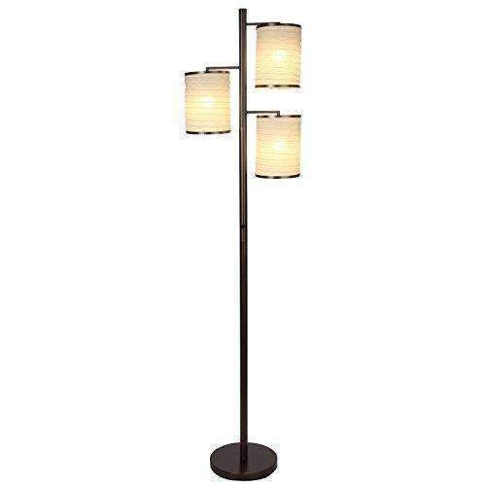

Slide 2

Make a slide base on below slide

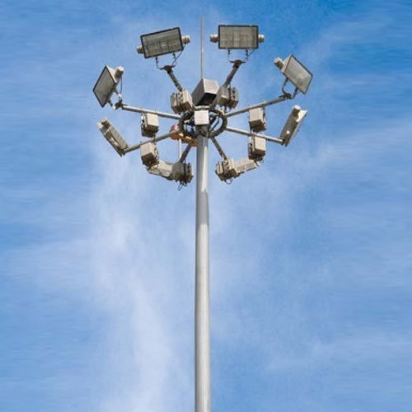

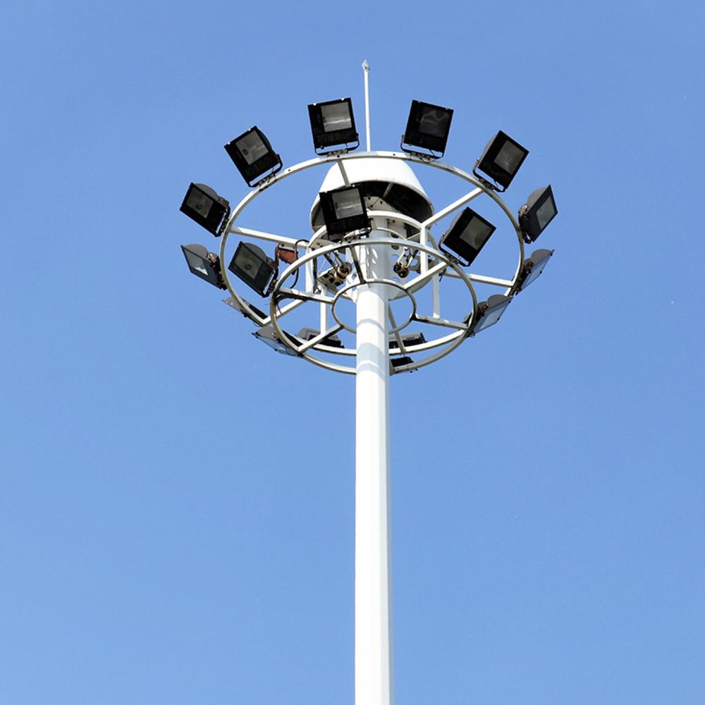

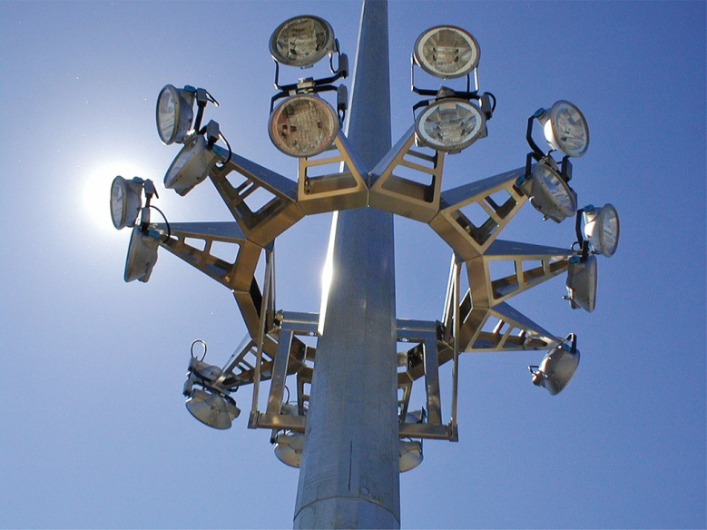

Slide 3

Make a slide base on below slide

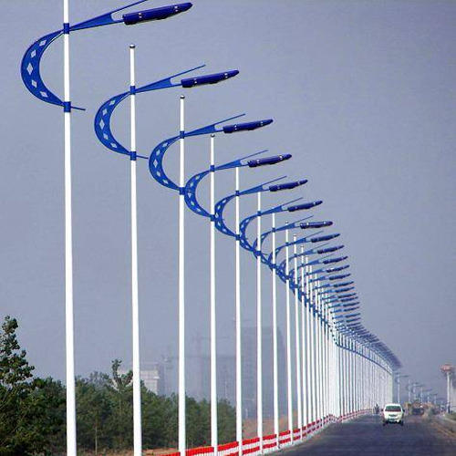

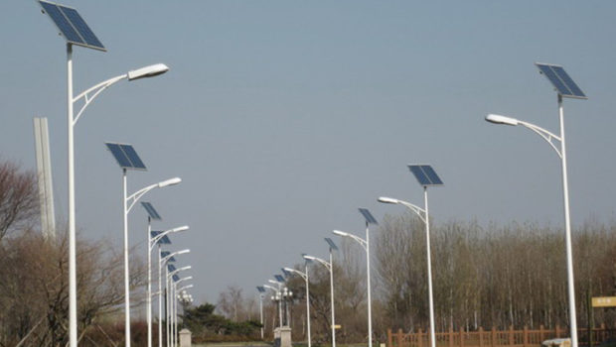

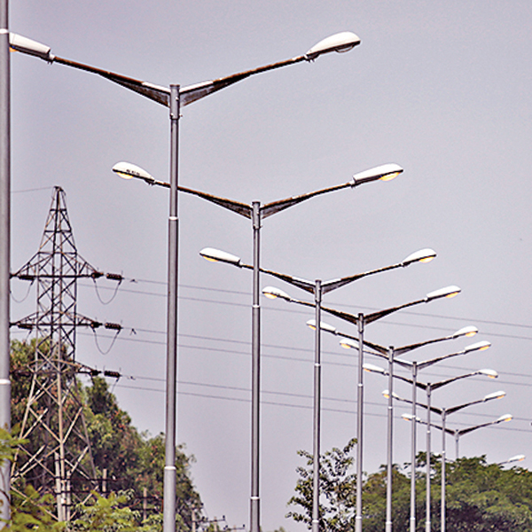

**Welcome to** **Vaishali Poles**

Established in the year**1997, Vaishali Poles**is one of the distinguished **manufacturer** immersed in the arena of presenting to our customers highly reliable **Swaged Pole, High Mast Pole, Bend Pipe, Junction Box,**etc**.**The personnel delivering these services are selected from some of the capable personnel present in the industry. Broadly cherished owing to its reliability, these offered services are highly acclaimed.

We make sure to fulfill the commitment of quality to diverse industrial regions, and we do this by presenting innovative product designs that meet the business goals of our esteemed clientele. Since the inception, we are striving to sustain the highest levels of integrity to synchronize soaring product needs with best quality pipes and fittings. We make sure to sustain ethical and transparent business deals and partner with credible vendor base to source premium grades of raw materials.  
  
Since we have incepted our base in this industry area, we are working underneath the direction of **Mr. Rahul Kumar Sharma**.

**Our Product**

**Decorative Pole**

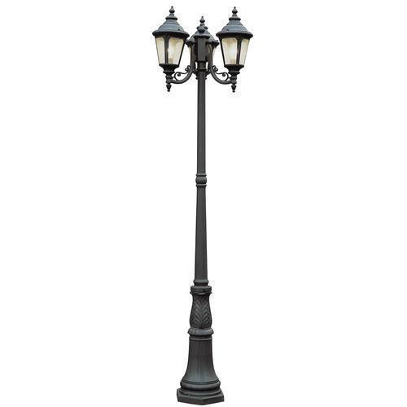

## High Mast Pole

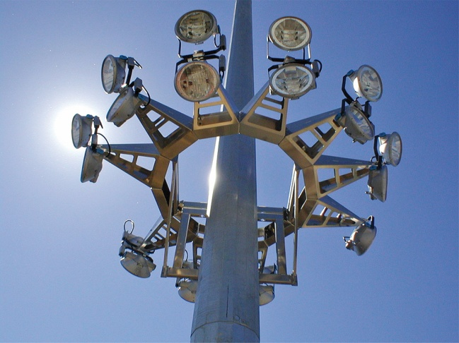

**Street Light Poles**

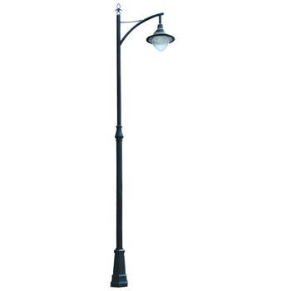

**Junction Box**

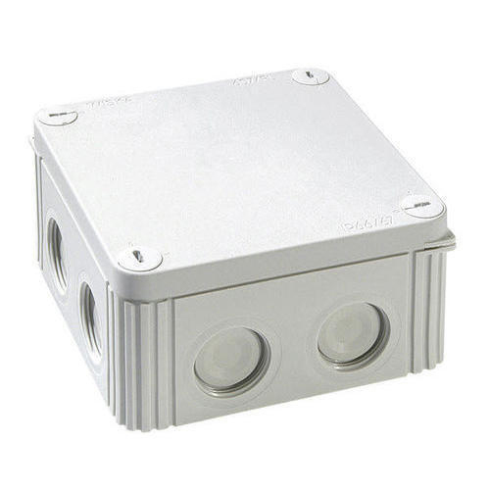

**Swaged Pole**

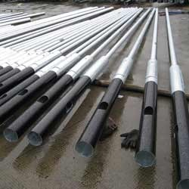

**Bend Pipe**

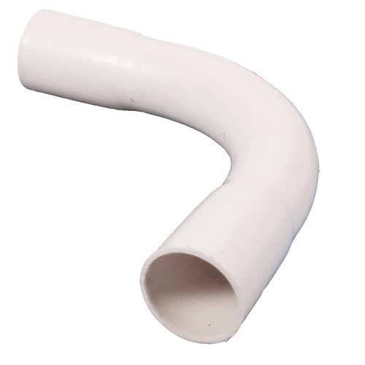

**Steel Tubular Pole**

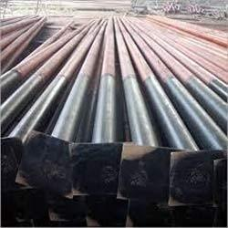

**Contact Us**

**Address – 237P / 1A, Satin Sen Sarani Kolkata – 700054**

**Mobile – 9051763430 / 9830539492**

**E – Mail – vaishalipoles2017@gmail.com**